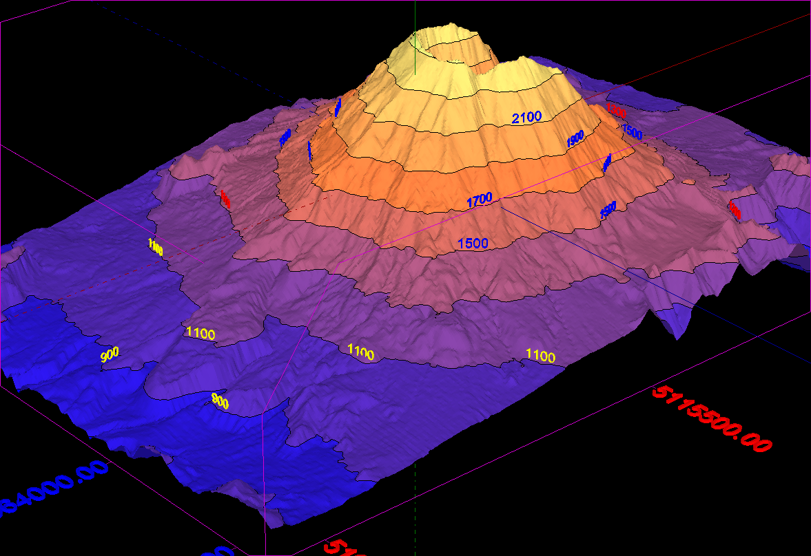
Building a Landform
Group Task

You need to build a geographically accurate model of your landform and use it and another mode (oral, I.T. based, audio visual, written, other) to prove your in-depth knowledge and understanding of your landform and to teach others.

Process
- Meet with your group and decide when you will meet up each week – twice is a good start.
- Find at least two examples of your chosen landform to base your research on. At least one example must be Australian.
- Answer the research questions FIRST (see below). You will not be given a building license until you have answered the P³ Presentation questions. It is recommended that you divide up the questions but the presentation of the questions must be combined. You may be asked any of the questions – whether it was your question or not.
- Plan and then build. You can use wood, cardboard, paper, plasticine, wire, chook fencing etc etc. Let us know AHEAD so we can order materials.
- Present your findings. This will be your first P³ (Publicly Presented Product) and will be presented in the Exhibition Centre to your parents and other students and teachers.

P³ Presentation Questions – Answer these first.
You must use your model and the answers to the following question in you presentation;
- Name your type of landform?
- Where are examples of this landform found? (Use a world map and a national map) Provide the latitude and longitudinal information.
- What do they look like? (Use photographs, movies etc, to illustrate real examples)
- How do these landforms form?
  - Explain the geographical processes using geographical terms and concepts. Is this true for all landforms of this type? Why/Why not?
  - Provide step by step diagrams and refer to them in your answer
- How is your landform used by humans? Consider agriculture, industry, transport, recreation, tourism etc.
- What is the value of your landform to the natural world?
  - Consider its relationship to other nearby landforms
  - Consider the value to plants and animals in the ecosystem
- How has human use of this landform altered it from its natural state? E.g. Nearby major developments.
- How do different individuals and groups see or value your landform? Consider the points of view of:
  - Environmentalists/Conservationists
  - Developers/Business
  - Governments
  - Local communities
Intellectual Stretch
Need a challenge? Build your landform model to scale. You will need to choose an example from somewhere on the planet and use maps to accurately scale your work.

