Year 8 Economics and Business

The Australian Market System and the Role of the Australian Government

Part 1:
- Students explain how markets operate and recognise why governments may influence the market’s operation.

It is important to understand the basic economic problems, especially the economic problem of scarcity, and why we all must make economic decisions. An understanding of the role of the government in the Australian economy, and how it intervenes in order to improve equality and wellbeing, is also important. Many Australians rely on welfare payments from the Government to survive. This is an example of Government intervention.

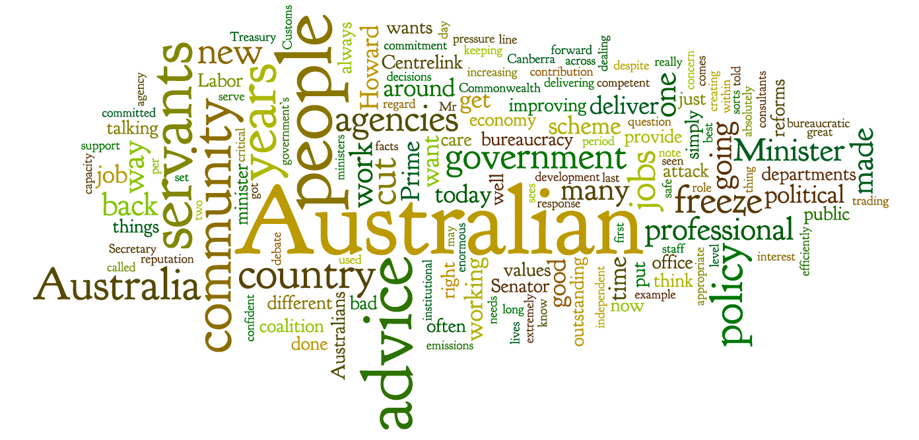

Australia is a mixed market economy. This means the government and the market make economic decisions that affect the economy. As a member of society it is useful for you to understand how and why governments make the decisions they do and how any changes affect the wellbeing and equity of Australia. These decisions affect everyone living in Australia, as well as overseas markets.

Let’s begin
We are all consumers of goods and services because we consume (use) products. As consumers in a market economy we have influence in determining both the types of products produced and how these are produced. The Australian economy is a mixed economy, with government intervening in the operations of the price mechanism. The Australian government intervenes in the economy for several reasons and in many ways.
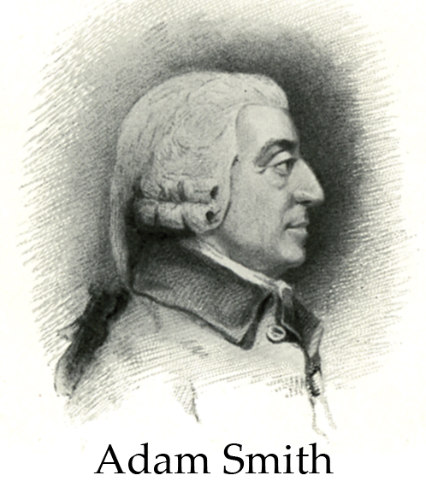
An economy based solely on producers and consumers with no government involvement is known as a market economy. This concept and idea has developed over time. In 1776, one famous philosopher and economist, Adam Smith (1723–90), wrote an important book in the development of economics called An inquiry into the Nature and Causes of Wealth of Nations. In Smith’s day people saw national wealth as measured by how much gold and silver a country had. All trade involved buying and selling goods with other countries. Importing (bringing goods into a country) was seen as a bad thing as wealth had to be given to the other country in exchange for goods. Exporting (sending goods to another country) was seen as good because it allowed the country to earn more gold and silver.

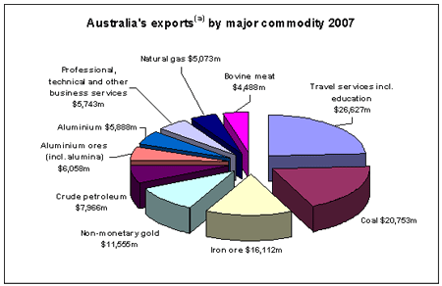
Many countries decided to put controls in place to stop gold and silver from leaving their country. This meant taxes and subsidies were given to those who sent goods to other countries (exporters). This resulted in restricted trade between countries and cities.
Smith argued that this was not in the best interests of society or the economy. He argued that there should be no restrictions and taxes, and by allowing free trade everyone would be better off. In other words, Adam Smith argued that the economy should be able to operate without any restrictions. This idea forms the basis of the ‘market economy’ and was taken up by many politicians at the time. Even today this forms the basis of free trade and market economies.
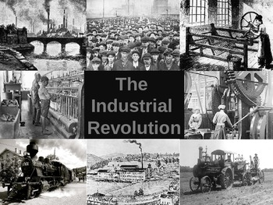
Until the Industrial Revolution, most people lived and worked on farms and life was based on a rural (country) lifestyle. Many farmers were self-sufficient (able to feed themselves by what they grew and the animals they raised).
In the eighteenth century there were many discoveries, such as Thomas Savery’s steam engine and the modern steam engine developed by James Watt. These discoveries allowed many industries and factories to be established. This included machinery in cotton mills, breweries, locomotives, and the coal and textiles industries. This, combined with ideas about free trade and market forces, allowed a market economy to develop.

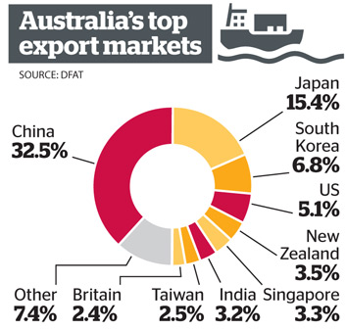
The Australian economy is based on a market (capitalist) system; however, there is also a role for the government in the economy. Therefore Australia, like many other economies around the world, is a mixed market economy. This can be defined as an economy based on the market system with government intervention. The governments in Australia, at the federal, state and local levels, interact with the economy through the government placing taxes on individuals and businesses (this allows them to gain revenue); through government expenditure such as health, education, and social welfare payments and benefits; and through the provision of services such as Australia Post.
Society as a whole expects the government to provide services and ensure that the economy is running properly. Therefore Australia has a mixed market economy.

Why the Government Intervenes
The Australian government intervenes to alter how Australian economic resources are allocated. This is done to keep the economy running smoothly rates and price rises (inflation). Governments aim to maintain a lack of economic downturn (depression) and periods of extreme economic boom, which create high inflation rates.
Government provides public goods and other essential products that the private sector would not provide. Some sectors such as health and education have both private and public ownership.

Advantages of living in a mixed economy
- Individuals are free to own property and operate businesses.
- A government-funded social safety net exists. This means that all people are guaranteed a minimum standard of living. Pensions and welfare payments protect us from what is known as absolute poverty.
- Governments provide services like health and education to protect the most disadvantaged Australians from absolute poverty.

Living in a mixed economy means we have:
- access to health care at public hospitals
- an entitlement to minimum wages and conditions (awards) under employee relations laws
- access to unemployment benefits
- access to pensions.
A pure market system would see none of these things available.

Fiscal policy intervention
Every year the Australian government outlines how much it intends to collect in revenue, like taxes, and how it intends to spend this money (the budget). If the government spends more than it collects in revenue, there is a budget deficit. When the government collects more than it spends, there is a budget surplus. A budget deficit has the effect of putting money into people’s pockets, so spending increases. This stimulates the economy. Governments do this when unemployment is rising and spending is low. But when the prices are rising (inflation) a government will often choose to have a budget surplus. This takes money out of circulation and slows the economy, reducing demand for goods and services. Governments use their budgets (fiscal policy) in order to keep the economy running smoothly.
Your Turn: Part 1
Short-answer questions

- List all the economic resources required for you to spend a day at school learning.
_____________________________________________________________________________________________________________________ /5

2. Summarise why Australia is defined as a mixed market economy.
_____________________________________________________________________________________________________________________ /2

3. Outline the reasons why the Australian government intervenes in the economy.
_____________________________________________________________________________________________________________________ /2

4. List five products provided by the public sector. Explain why the public sector provides these products.
Product provided | Reason why
/10

5. Describe two advantages and two disadvantages of the recent ‘Free Trade Agreement’ between Australia and China.
________________________________________________________________________________________________________________________
_____________________________________________________________________________________________________________________ /4

Part 2
- They explain why different types of businesses exist and describe the different ways businesses can respond to opportunities in the market.

- Small Business
- Franchise
- Online business
- Family business
- Home-based business
- Independent contractor
- Importer
- Exporter

Your Turn Part 2:

Choose 3 of the above business examples. Give a definition of each type of business. What are the advantages and disadvantages of each?

Business Type 1: ________________________________________________
_____________________________________________________________________________________________________________________________________________________________________________________________________________________________________________ /5

Business Type 2: ________________________________________________
_____________________________________________________________________________________________________________________________________________________________________________________________________________________________________________ /5

Business Type 3: ________________________________________________
_____________________________________________________________________________________________________________________________________________________________________________________________________________________________________________ /5

Which type of business would you choose as a small market stall operator? Why?
_____________________________________________________________________________________________________________________ /2

From the three business examples you have chosen, now choose one to answer the following:

Over a period of 6 months, you see a drop in sales. As a business owner, what are two actions could you take?
_____________________________________________________________________________________________________________________________________________________________________________________________________________________________________________ /4

A business moves into your area selling a very similar product to yours. What are two actions you could take?
______________________________________________________________________________________________________________________________________________________________________________________________________________________________________________ /4

There is a fall in the value of the Australian dollar. What would you need to do to ensure your business survives?
_____________________________________________________________________________________________________________________________________________________________________________________________________________________________________________ /4

Part 4
- Students describe influences on the way people work, and factors that may affect work in the future.

“By the year 2025, 50% of all current jobs will be performed by robots.”

Describe a job you believe will be taken over by robots? Discuss how effective you believe it will be.
_____________________________________________________________________________________________________________________________________________________________________________________________________________________________________________ /4

Describe a job you believe cannot be done by robots. Discuss why.
_____________________________________________________________________________________________________________________________________________________________________________________________________________________________________________ /4

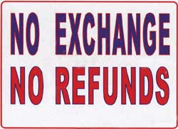
Part 3
- They explain the rights and responsibilities of consumers and businesses.

Straight over to you- In order to find the truth, this will take some extra research on your part.

1. You have just purchased a dress/suit for formal and you find out someone else has exactly the same outfit. They bought theirs online
from eBay and cannot (and won’t) return it. You go back to the store to seek a refund. What are your rights as a consumer? What are the rights of the business?

Or
2. You own a lawn-mowing round and Mrs Smith claims you mowed over her prize orchids. (You did but she didn’t tell you there was anything ‘special’ about them.) What rights does Mrs Smith have? What are your rights?

Or

3. Your own question.

Please use appropriate consumer/business vocabulary in your response and reference sources.
________________________________________________________________________________________________________________________________________________________________________________________________________________________________________________
________________________________________________________________________________________________________________________________________________________________________________________________________________________________________________
________________________________________________________________________________________________________________________________________________________________________________________________________________________________________________________________________________________________________________________________________________________________________________________________________________________________________________________________________________________________

References:
- http://www.wiley.com/legacy/Australia/PageProofs/ECODU/1_2/c01IntroductionAustraliaAMarketEconomicSystem_WEB.pdf Pg 3, 01/08/2015
- http://www.business.gov.au/business-topics/business-structures-and-types/Pages/default.aspx, 02/08/2015

